A SCRUTINY OF DUSSEHRA  
 -Anuj Narang

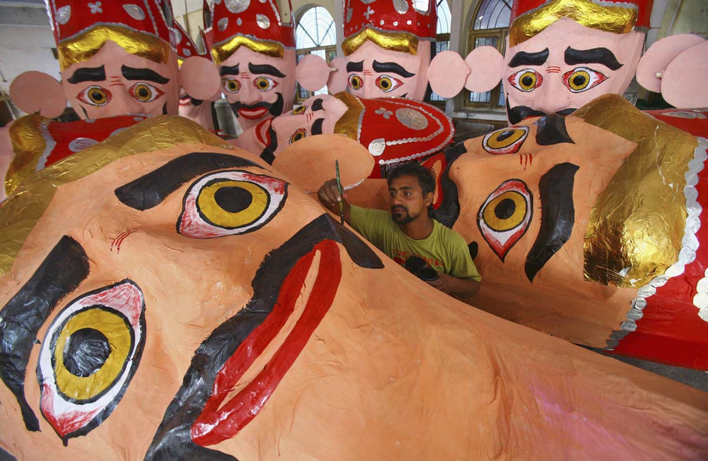

**The bona-fide evil**

The regime of visiting Ravana year after year on the eve of Dussehra has become intrinsic to our lives now. But let me tell you something. Something they do not tell you in those awe-inspiring mythology books. We do not just set his effigy on fire. Our act signifies sheer impudence. We practically spit on his soul by dishonouring him publically, tantalizing the demon across the nation. Yet that isn’t enough for we come back again the next year. And since it takes two to do the tango, the ‘Dashanan’ is bound to return. The cycle goes on. A total bummer!

That makes me wonder, what makes us go to the Dussehra ground and burn him down to ashes year after year? Do we really go there, having the thought of obliteration of evil in our minds? Or is it more of a getting-the-mind-off-stuff attitude that drives us there? Moreover, imparting such physical torture, bringing down those three colossal structures with a thud, why do we get that immense satisfaction? **When did we turn EVIL?**  
Well, it’s not our repugnance for the Lanka-lord that triggers the desire to give him a visit, but our affinity for the whole ceremony and the way it is done, that does the trick. The entire population joined at the hip, united around one idea- “The triumph of good over evil.” But in this case, evil cannot be shunned once and for all, for we love it too much.

**Comparison with an Indian Wedding**

The Dussehra ground glistens. The hubbub baffles me. The enactment of this barbaric yet creative drama is held across the country, enthralling large parades participating enthusiastically. It’s a jamboree for people of all ages. Exuberant and eager and dressed to their nines, the mob gets ready, gathering up for the merriment blood bath.

Overjoyed and euphoric are the little ones who leave no stone unturned to seize a spot in the front line of the crowd. Then there are the womenfolk, dressed impeccably in glittering saris and stunning dresses. They don’t really come to watch the Ravana, if you ask me. Nor they are interested in the other events going on. So what do they do there? Women are allowed to carry a deadly weapon wherever they go and can use it whenever they wish to. Their tongue! The elderly can also be seen sharing a gossip or two, imparting their wisdom and knowledge about the festival to the young ones. The amount of enthusiasm present in the ground could make Thomas Hobbes cringe in despair. A gush of excitement flows through all, as they wait for the ten-headed demon to bite the bullet.

And now days, things are getting even queerer, spiralling out of control. There is a post-burning celebration. Stalls of food snacks are spread over the ground with a stage and a DJ organized, as Ravana becomes the butt of myriad jokes. Yes. A DJ! Consuming some form of entertainment after such a visceral-act. We truly deserve it, don’t we? In a nutshell, I cannot spot much of a difference between the Dussehra ground and an Indian wedding ground, except for the three larger-than-life effigies.

**Man-work and Consequences**

With youths of the village working their socks off, every year they make it a point to improve upon the effigy’s height. Even a couple of superfluous feet require a Herculean effort. Working round-the-clock they craft the devil from wood and bamboos and use coloured papers for decorating it. The creation of an effigy is painstaking work, but the rewards are tangible, ranging from anywhere between Rs.1000 to 3.4 million right now.

And as he disintegrates, the entire year’s patience and efforts are lost in the winkling of an eye. Shouldn’t the time, effort and resources be invested on something more imperative and fruitful? But we would rather rely upon religion and mythologies than to act more rationally. No wonder they call us the Third World.

And, do we ever think of the ramifications caused by this civil commotion? It’s not only the mystical emperor we bring to knees. It’s also our environment. Noise pollution, harm to birds and animals, diseases from the release of harmful gases from fireworks, global warming; the list is endless. The sheer enjoyment of the overall ceremony puts blinkers over our eyes! Is there no healthier way of symbolizing the triumph of good over evil?

**The Best Part of it**

For eons I have been bothered a lot with this so-called festival, for I repeatedly found myself questioning the very foundations of it.

Let us recall that distasteful incident for a moment.  
According to our so-called Hindu Mythology, a king known as Ravana allegedly abducted a lord’s wife, took her to his country, did not even touch her once, treated her with respect and gave her food, clothing and shelter. Was it that horrific that we mortify him every year? A public holiday all over the country, so as to humiliate him in the evening, isn’t it a little too much of vindictiveness on our part? Shouldn’t we desist ourselves from doing this every year? I’m sure Ravana would like to bury the ghosts of his past.

As the social ills are budding each day, I ask you, why don’t you burn down effigies of assassins, rapists, and murderers? Do they not commit a crime more heinous than Ravana did? And how about crafting dummies of the modern day demons like crime, drugs, alcohol, lessons of hate and ugly gossip, and kindle them publically?

